1 initilaizing the folder

git init

2 save progress in system
git add .

3 git commit -m ‘describe-the-change’ m→ message

4 git log → to see changes

5 git checkout <here add the log SHA of the change>

6 git remote add origin https://github.com. [PUSH]
→
to upload the code to code base

7 git push -u origin master

8 to make new branch

git branch <branch-name> # Create the branch
git checkout <branch-name> # Switch to it

git checkout -b <new-branch>

//open that branch

git branch

how to merge into master branch

git push origin new-branch (git push the new-branch to origin)

to copy changes to your device

git pull origin master

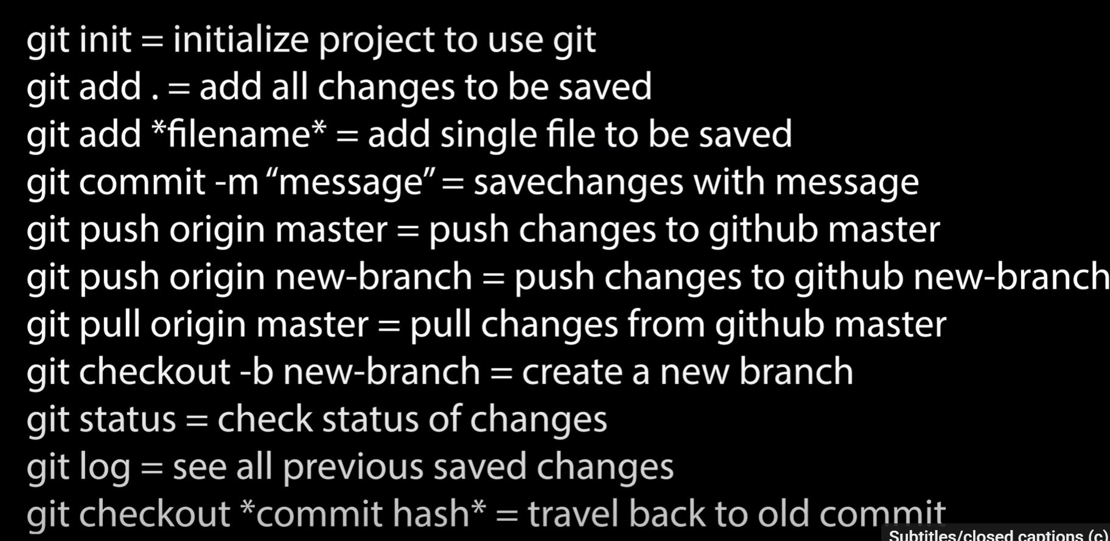

how to merge two branches

1) Switch to main branch

git checkout <branch_name>

git merge <branch to merger>

why Use origin in git push?
The syntax is:

sh
git push <remote-name> <branch-name>
origin = The remote repository (GitHub/GitLab).

backup_branch = Your local branch being pushed.

Without origin, Git wouldn’t know where to push your code!

Working with 2 people

git clone https:// <that forked url>

git remote add upstream <orignal_repo>

git remote -v [ to verify]

git checkout -b my_branch

git add .

Git commit -m “my_change”

git push origin my_branch

setup eamil at worker

git config user.email “prg2@tutamail.com”
git config user.name “prag666”

after all if your working again rebase it using this

git fetch upstream/<branch_name> to sync with the latest code in originalcode

git rebase upstream/main <rebase your work on top of the latest changes>

HOW TO UPDATE CHANGES TO THE CURRENT FORK
Check if upstream is already added:

bash
git remote -v

git fetch upstream/main update the latest code into your code

git rebase upstream/main Move my work on top of the latest updates.

